Title | Mrs | First Name | Tripti | Last Name |  | Anand | Photograph
Designation |  | Associate Professor |  |  |  |  | 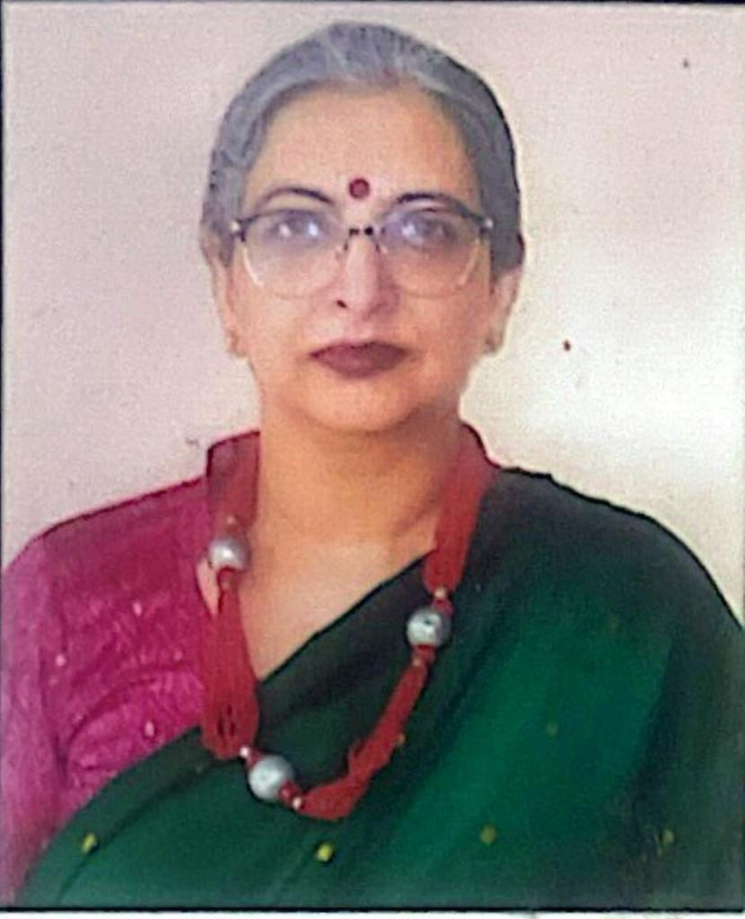
Department |  | Mathematics
Address  (Campus) |  | Shyama Prasad Mukherji College for women  Road no-57  Punjabi Bagh(west)  New Delhi-110026
Phone Number(Campus) |  | 25224499
Fax |  | 25221672
Email |  | triptimath@spm.du.ac.in
Education |  | MA in Mathematics , MPhil (Mathematics) ,Pursing Ph.D
Subject |  | Institution |  |  | Details
Mathematics |  | University of Delhi |  |  | MPhil
Research Interests/ Specialization
Non linear dynamics, Operator Theory

Teaching Experience
28 years
Publications:
Chapters in Edited Books :
1.Co-Edited a chapter-Quadratic equations and quadratic inequalities, in the Mathematics Senior Secondary self learning material of Board of open schooling and skill education, Sikkim, September 2022
2. Co-Author of a Chapter-Fundamentals of Differentiation , in the Mathematics Senior Secondary self learning material of Board of open schooling and skill education, Sikkim, May 2022.

Research Papers in Journals
1. An eye on symmetric group with CAS, IJRAR, 2023, 10 , 886-890 (ISSN no: 2349-5138)

2. Quasi minimizers,quasi efficiency and quasi saddle point criteria in optimization problems , IJRAR, 2023, 9 , 494-505 , (ISSN no 2349-5138)

Participation in International Conferences/Workshops:
- Participated in International symposium on Recent advances in differential equations and applications, 6 August 2024 ,Deshbandhu college.

- International conference on Advances in Pure and Applied mathematics ,8-10 February 2024 , Shyam lal college,DU (online).

- Refresher course from Ramanujan college ,13-26 July 2023
- Invited to attend 34 MID YEAR meeting , Indian academy of sciences, Bangaluru , 7-8 july 2023
- Scientific progam of lectures, Indian academy of sciences, Bangaluru , 6 july 2023
- Participated in International conference on graphs, networks and combinatorics , 10-12 January 2023, Ramanujan college,DU
- Participated in Workshop on NEP-2020, online, 29 July 2022, CPDHE
- Participated in Indian Women and Mathematics , Regional Workshop on Research and Opportunities ,IIT Bhilai , 21 February , 2021
- Participated in Faculty Training Progam on Microsoft Teams, 28-29 August 2020
- Participated in International Conference on Applicable Analysis organized by Shaheed Bhagat Singh College from 8-12 Feb 2017
- Participated in workshop on Foundation course “Building Mathematical Ability” conducted by CPDHE , University of Delhi , 15 -17 July, 2013.
- Participated in International Conference “The Legacy of Srinivasan Ramanujan” , 17-22 December, 2012
- Attended ICT workshop for capacity building of Delhi University faculty, organized by ILLL, 24 November-9 December 2009.
- Attended Workshop on “Applications of Mathematica at undergraduate level Mathematics” , UGC DRS-SAP Programme , 26 -27 March , 2009
- Attended International Conference on Operator Theory and related areas, 9-12 January 2008

Innovative Projects : A study of Student Absenteeism in Primary school in Delhi , 2012-13, DU.

Awards
- Awarded 5 Gold medals in M.A exams ,1995 , University of Delhi
- University Topper in M.Aand M.Sc( Math) ,1995, University of Delhi . Awarded Professor Ram Behari medal for being the Best candidate in the M.A and M.Sc Exam in Mathematics 1995
- Awarded Shri Ram Chandra memorial medal for being the Best candidate in the M.A/M.Sc exams in all subjects ,1995
- Awarded J.N.Mitra memorial medal for being the Best candidate in the M.A/M.Sc exam in mathematics,mathematical statistics and M.Sc in Physics (taken together) 1995
- Awarded M.Makhan lal medal for being the Best candidate in the degree examination held in 1995
- Awarded Shrimati Sivakamamma Radhakrishnan Medal for being the Best women candidate in M.A examination held in 1995.
- Awarded Ravi Kanta Devi Prize for being the Best Women Candidate in B.A (Hons) exams , 1993 ,University of Delhi

Other Responsibilities:
- Member of course review comtt. , constituted by Central Institute of Education ( CIE) , University of Delhi, for B .El.Ed optional paper of Mathematics ,2016-2019

- Convenor Eco-Club 2021-22 and 2022-23.( Got letter of appreciation from TERI and PCRA) and Eco club -Convenor 2015-16 , co convenor 2014-15
- Coordinator of Guru Nanak studies centre from 2013-15 (established by UGC) and Member of Guru Nanak Studies Centre 2007-15.
- Organising member of FDP/Workshop/seminars-

- Organised as coordinator, the Science Academies lecture workshop, 5-7 January 2023, sponsored by the 3 science academies of India.

- Organised workshop on Air pollution in collaboration with DEEP-C and Lung care foundation, 14 December 2022.

- Coordinator of one day seminar on Expanding the domain of indian languages in mathematics and science -18 november 2022, sponsored by Bharatiya Bhasha Samiti, Ministry of Education , Govt of India.

- Coconvenor , UGC Sponsored National Seminar on “Applications of Mathemtics in Social Sciences” , 3-4 th March 2022

- Co Convenor of National workshop on Groups and Geometry(for lecturers) , 2-3 August 2019 , in collaboration with The Indian Mathematics consortium.

- Co Convenor of two day National workshop on “Energy conservation and environment” organised by SPM College in collaboration with Petroleum Conservation and Research Association (PCRA) , Ministry of Petroleum and Natural Gas , Govt. of India , 1-2 February 2019

- Member of organising team of two day National Seminar on “Formation and Usage of Technical Terminology in Higher Education, jointly organised by SPM College and Commission for Scientific and Technical Terminology , Ministry of Human Resource Development , Govt of India , 29-30 October 2018
- Teacher in charge –Science Academies’ Lecture Workshop (sponsored by the 3 Science Academies of India) , 11-13 October 2018

- Co Convenor of Interdisciplinary Faculty Development Program on “Effective Teaching and Learning Practices”- 22-26 September 2018.

- Paper setting of DU exams ,Hons and BA (Prog) and External practical examiner
- Member screening committee of Mathematics and Computer science, 2022-23.
- Coconvenor ,55 th Annual Day,2023-24
- Member of Governing Body
- Department Incharge 2017-19
- Member Research and Ethics committee of college 2018-19.
- Member of IQAC , 2018-19
- Member Of Golden Jubilee Committee of College 2017-19.
- Orientation Committee convenor 2020-21, 2019-20 ,2013-14 , 2009-10 , co convenor- 2018-19 and 2012-13 and 2008-09.
- Member Timetable comtt 2015-16
- Convenor of B.A (prog) Coordination Comtt 2014-15
- Member of college organising comtt of Antardhvani (University Fest) 2013-14
- Member of Examination comtt. of college 2013-15
- Member of Enabling unit of college ,Equal opportunity cell 2012-15
- Convenor 42 nd , Annual Day 2011-12 , CoConvenor 2010-11
- Convenor Fee concession comtt.
- Member screening committee of Mathematics and Computer science, 2022-23.
- Coconvenor ,55 th Annual Day,2023-24

