Curriculum Vitae (CV)

Title | Dr. | First Name | Manas | Last Name |  | Anand | Photograph
Designation |  | Assistant Professor |  |  |  |  | 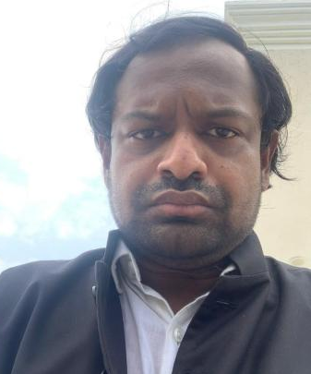
Department |  | Geography
Address  (Campus) |  | Deptt of Geography, Shyama Prasad Mukherji College, Univ of Delhi
Phone Number(Campus) |  | N. A
Fax |  | N.A
Email |  | manas@spm.du.ac.in
Education |  | M.A, Ph.D.
Subject |  | Institution |  |  | Details
- |  | - |  |  | -
- |  | - |  |  | -
- |  | - |  |  | -
Research Interests/ Specialization
-
Teaching Experience
5 Years
Publications:
Research Papers in Journals:

Participation in International Conferences/Workshops:

Organizing Seminars/Conferences/workshops, other college/university activities .
Innovative Projects:

Awards/Recognition:
Other Responsibilities:
Refresher/orientation course/ Faculty Development Programme

Examination and evaluation duties assigned by college/university or attending the examination paper evaluation.

