Curriculum Vitae

Title | Mr. | First Name | Shashank Kishor | Last Name |  | Singh | Photograph
Designation |  | Assistant Professor |  |  |  |  | 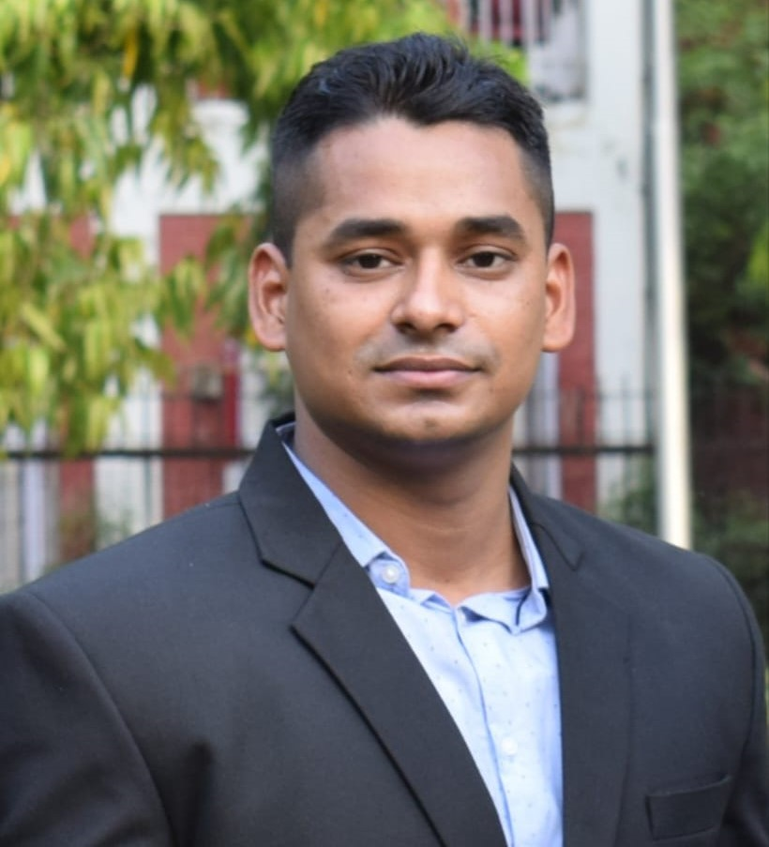
Department |  | Geography
Address  (Campus) |  | WZ-201, Lajwanti Garden, Janakpuri,  Delhi- 110046
Phone Number (Campus) |  | 9873755858
Fax
Email |  | shashanksingh1910@gmail.com
Degree |  | Institution |  |  | Year
Ph.D. |  | Dept. of Geography, DSE, University of Delhi.
M. Phil. |  | Dept. of Geography, DSE, University of Delhi. |  |  | 2021
M. A. |  | Dept. of Geography, DSE, University of Delhi. |  |  | 2019
B. A. (Hons) |  | Dept. of Geography, Institute of Science, Banaras Hindu University |  |  | 2017
Others |  | UGC- NET/JRF |  |  | 2019
Research Interests/ Specialization
Natural Resource Management, Climatology, Environmental Geography, Geo-environmental Applications, Water Resource Management, Traditional and Cultural Knowledge.
Teaching Experience
5 Years
Other Responsibilities
Coordinator- NCC, SPMC Unit (2021-2025).
Member- Admission Committee, B.A. (Prog.) (2021-2024)
Convenor- Alumni Committee of the Department of Geography, SPMC (2024-2025).
Convenor- Alumni Committee of the Department of Geography, SPMC (2023-2024).
Convenor- Magazine Committee of the Department of Geography, SPMC (2022-2023).
Convenor- Magazine Committee of the Department of Geography, SPMC (2021-2022).
Co-convenor- Cultural Committee of the Department of Geography, SPMC (2023-2024).
Co-convenor- Academic Activities Committee of the Department of Geography, SPMC (2022-2

