Curriculum Vitae (CV)

Title | Prof. | First Name | Rachna | Last Name |  | Dua | Photograph
Designation |  | Professor |  |  |  |  | 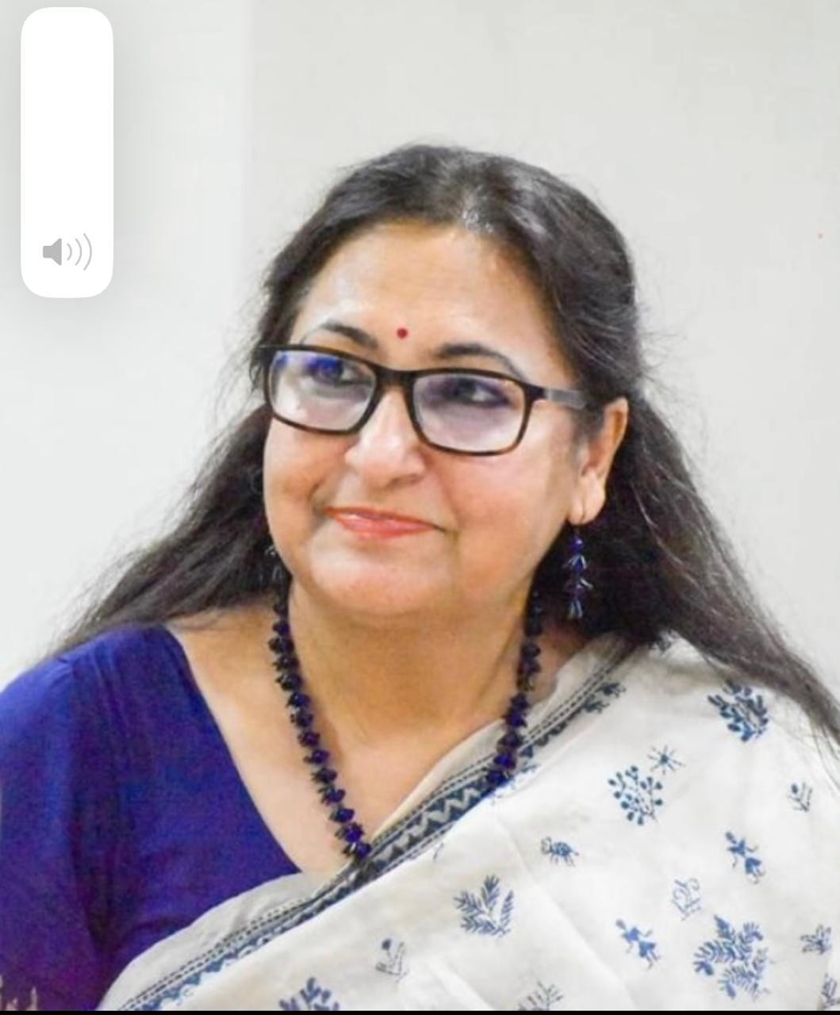
Department |  | Geography
Address  (Campus) |  | Deptt of Geography, Shyama Prasad Mukherji College, Univ of Delhi
Phone Number(Campus) |  | N. A
Fax |  | N.A
Email |  | rachnadua456@gmail.com
Education |  | M.A, M.Phil, B,Ed, Ph.D.
Subject |  | Institution |  |  | Details
- |  | - |  |  | -
- |  | - |  |  | -
- |  | - |  |  | -
Research Interests/ Specialization
Agricultural Geography, Climatology, Geo -Politics
Teaching Experience
29.5 Years
Publications:
Research Papers in Journals:
- Dua, R. (2022). Improving use of crop residues in India. International Journal of Farm Sciences, 12(3), 44-53.
- Dua, R. (2022). Geopolitical implications of belt and road initiative with special reference for India. National Geographical Journal of India, 68(2).
- Satpal & Dua, R. (2023). Role of agricultural extension services in dryland farming with special reference to Nagaur and Shekhavati regions of Rajasthan. International Journal of Agriculture Sciences, 15(7), 12496-12501.
- Dua, R. (1994). Agricultural production in Haryana. Third Concept, 8(88), 35-37.
- Dua, R., & Mohammad, N. (1998). Spatial variations in the levels of agricultural development in Haryana. The Geographer (AMU), XLV(1), 16-31, https://api.amu.ac.in/storage//file/journal/9933.
- Dua, R. (in press). Shaping battlefield with emerging technologies. National Geographical Journal of India ,https://www.ngji.in/index.php/ngji/issue/view/60
- Satpal & Dua, R. (2023). Status of dry land farming in Nagaur and Shekhawati regions of Rajasthan. International Journal of Research and Analytical Reviews (IJRAR) , 10(2), 994-1004 , http://www.ijrar.org/papers/IJRAR23B2125.
- Md. Arif Husain, Pankaj Kumar, Anju Singh, VAV Raman, Rachna Dua and Swati Thakur “Snow Cover and Snowline Variation in Relation to Land Surface Temperature in Spiti Valley, Himachal Pradesh”, India November 2022 International Journal of Ecology and Environmental Sciences 49 (2)
- Jaiswal, S., Anand, S., Singh, D., Kaur, U., Dua, R., & Lal, B. (2023). Accessing the food security component of households in Dimapur, Nagaland. Sustainability, Agri, Food and Environmental Research, 11(2023), 1-18.
- Jamal, S., Upadhyay, A., & Dua, R. (2024). Crossing the Seven Seas: Covid 19 induced migrant crisis with reference to Uttar Pradesh. Sustainability, Agri, Food and Environmental Research (SAFER) , 12(2024), 1-33.
- Srivastava, A., Sharma, P., & Dua, R. (2019). Hydrological dynamics and hydroelectric projects in Indian Himalayas: A case study of east Himachal Pradesh. International Journal of Creative Research Thoughts (IJCRT) , 7(1), 473-485, https://ijcrt.org/download.php?file=IJCRT1134087.pdf
- Jamal, S., Upadhyay, A., & Dua, R. (2021). Indigenous people and changing socio-cultural behavior: A case study of Toto tribes, Totopara. Sustainability, Agri, Food and Environmental Research (SAFER), 9(3), 369-385.
- Prakshi, Lipika, Priyanka, Anjali, Dua, R., Upadhyay, A., & Prakash, P. (2023). Traffic congestion in Delhi and sustainable daily practices. Journal of Applied Research in Humanities, Language and Social Sciences , 2(2), 25-40, http://www.jarhlss.com/
- Srivastava, A., Sharma, P., & Dua, R. (2019). An overview of hydropower development in Hangrang valley, Himachal Pradesh. Journal of Emerging Technologies and Innovative Research (JETIR), 6(2), 1664-1673.

Participation in International Conferences/Workshops:
- 1. The paper "Improving the Use of Crop Residues in India" was presented at the International Conference of the Deccan Geographical Society of India on November 9, 2021, at the Centre for Geographical Studies in Patna. The presentation focused on the importance of effective crop residue management in India and explored potential strategies for optimizing its utilization.
- I spoke on "Encouraging Greater Participation and Leadership of Women in Disaster Resource Person Training" at the National Institute of Disaster Management (NIDM), Ministry of Home Affairs, on January 13, 2021as a resource person. The 30-minute presentation focused on the importance of empowering women to take on leadership roles in disaster preparedness and response.
- As a resource person , I presented the findings of Innovative research work "An Exploratory Study of Environmental Awareness and Consumer Behavior towards Eco-Friendly Household Products" as a PI at a seminar organized by the Innovation Project of Delhi University on April 16, 2013. The 20-minute presentation explored the current state of environmental awareness and consumer preferences for eco-friendly household products.
- I presented the paper "Impact of Globalization and Liberalization on Indian Agriculture" as part of a UGC-sponsored refresher course on December 30, 2003. The 20-minute presentation explored the effects of globalization and liberalization policies on Indian agriculture, including both positive and negative impacts.

Organizing Seminars/Conferences/workshops, other college/university activities .
S. No. | Year | Details | Place | Period
 |  |  |  | From | To
1 | 2023 | Coordinator: Invited Talk on  “Geographies of Gender: Issues approaches and experiences”  Resource Person: Prof. Anindita Datta, Head, Dept of Geog , Univ of Delhi | Conference Room No 28, | 12 th April, 11.30 am
2 | 2022 | Coordinator: One day “QGIS” Workshop Resource Person: Prof. Pankaj Kumar, Dept of Geog , Univ of Delhi | Room no 311 and GIS lab 302 | 14th Sept, 9.00 am to 5.00 pm
3 | 2022 | Convenor: One day Seminar “Human- River relationship- A Socio- Cultural-Environmental Perspective in the 21^{st’} century”  - Sri Shankarnandji, Akhil Bharatiya Seh Sangathan Mantri, Bharatiya Shikshan Mandal  - Prof. Ravi P. Tekchandani, Dean, Recruitment and Promotions, Univ of Delhi  - Prof. Tejbir Singh Rana , Shivaji College, Univ of Delhi | College Auditorium | Jan 31
4 | 2021 | Convenor: One day seminar on “AatmaNibhar Bharat’  Resource Persons:  - Prof Kaushal Kumar Sharma  - Ms. Ilma Afroz  - Prof. Vandana Sharma | Conference Room | 22nd Sept
5 | 2021 | Convenor: Webinar “Role of Indo- Tibetan Border Police Force ITBPF in Himalayan Rescue Operations with special reference to Tapovan Disaster’ Resource Person: Mr. Vivek Kumar Pandey, 2nd –in-Command/ PRO, ITBP | Google meet | 7 April
6 | 2021 | Coordinator: Three days FDP cum Training Workshop “Geo-Spatial Technology, Inclusive and Accessible Disaster Risk Reduction “(DRR)  Chief Guest: Major General Manoj K Bindal, Executive director, NIDM  DAY 1  - SPEAKER 1- Prof. P.K Joshi, Chairperson (SCDP), Prof. SES.  TOPIC-Geoinformatics for Disaster Risk Reduction.  - SPEAKER 2- Er. Awdhesh Kumar, Invertis University.  TOPIC- Science and Technological Innovation for Disaster Risk Reduction  - SPEAKER 3- Prof.(Dr.) Devesh Walia, NEHU, Shilong  TOPIC- Role of Geo-Spatial Technology in Earthquake Hazard/ Disaster Risk Resilience.  DAY 2  - SPEAKER 1- Sh. Ashish K. Panda, Consultant, and Faculty Member, NIDM  Topic- There is no greater disability in society than the inability to see a person as more.  - SPEAKER 2- Miss Ankita Gulati, Founder, and CEO- Touch Vision  Topic- Role of technology for persons with disabilities in disaster risk reduction.  - SPEAKER 3- Prof. Girish Chandra Mishra, OPJU, Raigarh  Topic- Psycho-Social Care for Persons with Differential Abilities.  DAY 3  - SPEAKER 1- Dr. Bindy Wasini Pandey  Topic- High Altitude Disasters And Vulnerabilities.  - SPEAKER 2- Vishwambhar Prasad Sati  Topic- Disaster Risk Management / Reduction.  - SPEAKER3- Mr. Md. Arif Husain  Topic- Disaster Risk Management and Reduction in the Himalayan point of view | Online (MS Teams | March 04 - | March-06
7 | 2021 | Coordinator: Panel Discussion Encourage greater participation and leadership of women in Disaster management  - Resource Person: 1 Prof. Girish Chandra Mishra OPJU, Raigarh.  - Resource Person 2: Dr. Preeti Bansal, Joint Secretary, O/o PSA to GOl.  - Resource Person 3: Dr. Rachna Dua, TIC and Coordinator.  Resource Person 4: Sh. Ashish K. Panda Faculty Member, NIDM | Online Google meet | January 13
8 | 2020 | Convenor: Webinar, Geo informatics for Contemporary issues  Resource Person: Prof. P.K Joshi, JNU | Google meet | September 26
9 | 2020 | Convenor: Webinar,  Dealing with disasters  Resource Person: Dr. Rakhi Parijat, Associate Prof., Miranda house | Google meet | May 4Th
10 | 2019 | Convenor: Invited Special Lecture  “The Consequences of Urbanization: The Case in Delhi”  Resource Person: Prof. V.K Tyagi, SBS College, Univ of Delhi | Conference Room | 23rd October
11 | 2019 | Convenor: Two days’ Workshop  “Geo – Spatial technologies” | Geography Labs | 3rd | 4Th October
12 | 2019 | Convenor: Invited Special Lecture  “Application of remote sensing with reference to Atmospheric studies”  Resource Person: Mr. Amit Kumar, Scientist C, IMD, New Delhi | Conference Room | 4th September
13 | 2019 | Convenor: Invited Special Lecture “Disaster Management” Dr. Amrita Bajaj, | Conference Room | 6 th February
14 | 2018 | Convenor: Invited Special Lecture “Dynamics of Lithosphere”. | Conference Room | 31 st October
15 | 2018 | Convenor: Inaugural ceremony of Geography Hons  Chief Guest: Prof. Rai, Head, Dept of Geography, Delhi School of Economics, Univ of Delhi.  Guest of Honour and Resource person: Prof. Anu Kapur , Head, Dept of Geography, Delhi School of Economics, Univ of Delhi.  Guest of honour: Shri Amrish Tyagi, Chairman, SPM College | College Auditorium | Sept 5
Innovative Projects:
S. No | Title | Period |  | Major/Minor | Sponsoring/Funding Agency
S. No | Title | From | To | Major/Minor | Sponsoring/Funding Agency
1 | Innovation Project 102 “Exploratory Study of Environmental Awareness and Consumer Behaviour towards Eco-Friendly Household Products” | 2012 | 2013 | Minor | Univ of Delhi

Awards/Recognition:
1. Introduced Geography (Hons) in the college and Set up Two well equipped Labs Viz. Cartographic Lab and GIS Lab.
2. I received the Best Paper Award for my article entitled “Improving Use of Crop Residues in India” published in “International Journal of Farm Sciences”: on December 9th, 2022, from the Society for Advancement of Human and Nature (SADHN), Dr YS Parmar University of Horticulture and Forestry in Nauni, Solan, Himachal Pradesh, India.
3. Member, Departmental Research Committee , (DRC) , dept of Geography , Delhi School of Economics, Univ of Delhi
4. Member, Committee of Courses dept of Geography , Delhi School of Economics, Univ of Delhi
Other Responsibilities:
1. I have successfully supervised a Ph.D. student at the University of Delhi. The student's Thesis, titled 'Sustainability of a Rural Region: Spatial Analysis of Dryland Farming in Shekhawati and Nagaur Regions of Rajasthan,' was completed and awarded in 2019.
2. Administrative responsibilities such as Head/Dean/Director/coordinator, warden etc.
S. No | Nature of Activity | Designation | Institution/Department | Period
 |  |  |  | From | To
1. | Administration | Head of the dept | Geography | 1998 | March 2024
2 | Administration, Coordinator Selection panel _Geog | Coordinator | Geog dept, SPM | 2016, 2018 2019 | --
4 | Administration  DRC | Member | Department of Geography  Delhi school of economics | Sept 2008 | Sept 2010.
5 | Administration, Examination Committee: | Member, Nodal Officer | SPM | 2021  2022 | 2022  2023
6 | Administration, CBCS : | Co- convenor | SPM | 2019 | 2021
7 | Nadi-ko-Jano Abhiyan”: | Nodal Officer | SPM | 2021 | 2022
8 | Screening Committee: | Convenor/ In charge | SPM | 2022 | 2024
9 | Administration, Admission: | Member | Geography | 1998 | March 2024
10 | Academic Supervisory committee: | Member | SPM | 1998 | March 2024
11 | Orientation Committee: | Convenor and co convenor | SPM | 2008 | 2010
12 | General Knowledge Committee: | Convenor and co convenor | SPM | 2010 | 2012
14 | Cleanliness Committee: | Convenor and co convenor | SPM | 2012 | 2013
15 | Environmental studies: | Convenor | SPM | 2013 | 2014
16 | Eco Club: | Convenor | SPM | 2014 | 2015
17 | Debate Committee: | Convenor and co convenor | SPM | 2014 | 2016
18 | General Knowledge Committee: | Convenor and co convenor | SPM | 2017 | 2019
19 | Prize Distribution Committee: | Member, Anchor | SPM | 1998,  Once | March 2024
20 | Library Committee: | TIC Member, contributed in the purchase of all Geog Books | SPM | 1998 | March 2024
Refresher/orientation course/ FacultyDevelopment Programme

S. No. | Details | Place | Period |  | Year | Sponsoring/Organizing Agency
S. No. | Details | Place | From | To | Year | Sponsoring/Organizing Agency
1. | 4-week Orientation course | New Delhi | 9th April | 4th May | 2001 | JNU
2. | Eight weeks certificate course- GIS Technology and Applications | Dehradun | 5th May | 26th June | 2003 | Indian Institute of Remote Sensing, Dehradun
3 | Refresher course | New Delhi | 9th Dec | 30thDec | 2003 | UGC - CPDHE
4 | Introduced new course -Geography Honours (Running) | SPM | July 2018 |  | Till date | SPM
5 | Academic Congress | Vice regal Lodge, University of Delhi | 6th Sept | 7th Sept | 2012 | Univ of Delhi
6 | 9th International Geographical union (IGU) Conference |  | 18 th March | 20th March | 2016 | SBS College, univ of Delhi
7 | Art of thesis Writing-Webinar | Online | 7Th April. 12:00 PM |  | 2020 | Dr. Namita Rajput (Principal,SAC(E)) and SPMC
8 | Urban health and preparedness in Global Pandemic-Webinar | Ohttps://us02web.zoom.us/j/83226300170?pwd=bDlvVGNKTTBzUFEvQWZ3S2swRENNZz09  MeetingID:83226300170  Password: 6hAyCDonline | 29 Th April 2:30 to 4:30 pm . |  | 2020 | NIDM and SBS College
8 | Transformative power of mentoring-webinar | Join Zoom Meeting https://us04web.zoom.us/j/6580163544?pwd=K1Y3cUZyWllGNndTNDlray8vbFl4QT09 Meeting ID: 658 016 3544 Password: 196053 | 9Th May |  | 2020 | IQAC, SPMC
9 | Participated in International E-Quiz competition | ONLINE | 20 August |  | 2020 | department of Geography, D.A.V college, Ambala
10 | FDP  “From Research to Publications”  Zoom Link: https://zoom.us/j/95148346900 | Online | April 5 | April17 | 2021 | Mahatma Hansraj faculty development centre, Acharya Narendra Dev College
11 | Academic leadership programme for Academicians | Online | March 22 |  | 2021 | BSM and NITI Aayog and CPDHE
12 | International Conference, SAGGA -7 – The Future of Arctic Ice: An Indo Pacific Connect | India International Centre, Lodhi Road | 27th April | 28th April | 2023 | LIGHTS- Learning in Geography, Humanities, Technology and Science -A think tank .
Examination and evaluation duties assigned by college/university or attending the examination paper evaluation.
S. No | Nature of Activity | Designation | Institution/Department
 |  |  |  | date
1 | Moderation | Member | Delhi school of Economics | 25/04/2023
2 | Course committee mtg / syllabus formation NEP | Member | Delhi school of Economics | 20/4/2023
3 | Practical Paper -field | Internal Examiner | SPMC | 20/04/2023
4 | Paper setting | Member | Delhi school of Economics | 17/04/2023
5 | Course committee mtg / syllabus formation NEP | Member | Delhi school of Economics | 06/04/2023
6 | Paper setting | Member | Delhi school of Economics | 24/02/2023
6 | Examination prog LOCF GE | Paper setter | Delhi school of Economics | 01/08/2022
7 | Examination prog LOCF Core | Paper setter | Delhi school of Economics | 01/08/2022
8 | Examination | Paper setter | Delhi school of Economics | 27/07/2022
9 | Examination | Paper setter | Delhi school of Economics | 18/07/2022
10 | Practical Exam | Internal Examiner | SPM | 12/7/ 2022
11 | Examination | Paper setter | Delhi school of Economics | 11/07/2022
12 | Examination-Physical Geog | Paper setter | Delhi school of Economics | 10/11/ 2021
13 | Paper setting -Population Geog | Paper setter | Delhi school of Economics | 10/11/ 2021
14 | Paper setting -world economic Geography | Paper setter | Delhi school of Economics | 10/11/ 2021
15 | Examination (3 attachments) | Paper setter | Delhi school of Economics | 08/11/2021
16 | Evaluation -Population Geog | Evaluator | Delhi school of Economics | Nov-Dec 2020 exams
17 | Evaluation – Geog of India | Evaluator | Delhi school of Economics | Nov-Dec 2020 exams
18 | Evaluation -climatology | Evaluator | Delhi school of Economics | Nov-Dec 2020 exams
19 | Evaluation -General Cartography | Evaluator | Delhi school of Economics | Nov- Dec 2020 exams
22 | Examinership – Ph.D thesis “Shelter environment and Settlement planning in west Bengal: A comparative study of east and west Medinipur districts”1 | Examiner | Utkal Univ, Odisha | 18/12/2018

- Student related co-curricular, and field-based activities study visits, student seminars, and other events.
S. No | Nature of Activity | Level  (PG/ UG) | Institution/  Department | Period
 |  |  |  | From | To
1 | Formed Geography Association ‘DHARA’ as a TIC | UG | Geography | 2019 | March 2024
2 | Conducted Election to the student council of Geography Association as the TIC | UG | Geography | 2019 | March 2024
3 | Coordinated Academic Field Visits | UG | Geography | 1998 | March 2024
4 | Introduced publication and release of annual departmental E magazine ‘Milieu’ as the TIC | UG | Geography | 2019 | March 2024
5 | Put up a Stall at Antardhvani | UG | Univ of Delhi | 2013
6 | Organized various student activities as the TIC  - Orientation of new batch of students  - Fresher’s party  - Student council events  - Career Counselling  - Preperation for entrance Exams  Poster Making | UG | Geography | 2018 | March 2024

